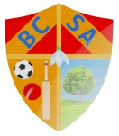
BROUGHTON COMMUNITY & SPORTS ASSOCIATION (BCSA)
Extraordinary Meeting Minutes

Sunday 6th November 2016

Present:
Sean Clixby (Chairperson), Steve Hayton (Treasurer), Martin Hempstock, Ann Wood (Secretary), Neil Simpson (Vice-Chairperson)

Apologies:
Roger Bonnett, Peter Clixby

Charity Application (SC):
Sean had been contacted regarding our application for charity status and we needed to make some amendments to our Constitution. Sean had gone through the constitution and made the amendments which we discussed.

We all agreed with the amendment to the Constitution and this was proposed by Martin Hempstock and seconded by Steve Hayton.

The four Trustees agreed to let Sean Clixby send off the new Constitution and sign these minutes of behalf of all Trustees to acknowledge the amendments made.

AOB:
None to be discussed.

Meeting closed at 4.40pm

Signed:
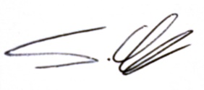

Sean Clixby
(BCSA Chairperson & Trustee of BCSA)

Date:
Sunday 6th November 2016.

